PROGRAMMING LANGUAGES

ACTIVITY. Comprehensive Git Lab: Local to Cloud & Clone to Branch

Name: | PACIA, PAULINE GAE P.
Section: | III-DCSAD
Date: | 4/18/2026

Comprehensive Git Lab: Local to Cloud & Clone to Branch
Duration: 2 Hours Tools: Git CLI, GitHub Account

Concept
Students experience the core Git workflow by managing a local project across the Working Directory, Staging Area, and Repository. You will initialize a project, branch safely, intentionally trigger and resolve a merge conflict ("salpukan"), and push code to the cloud to open a Pull Request.
Part 1: The Git Workflow - Local to Cloud
Section A: The Three Zones of Git
Students initialize a local repository and learn how to track file changes offline. They will use the core Git workflow to move files through the Working Directory, Staging Area, and Repository.

1. Local Initialization & Committing
- Create a new project folder and add a basic text or code file.
- Initialize the folder using git init.
- Check the status using git status.
- Move the file to the "waiting room" (Staging Area) using git add ..
- Save it safely to the vault (Repository) using git commit -m "Initial commit".
- Verify the project history using git log.

Screenshot/s of Section 1.A.
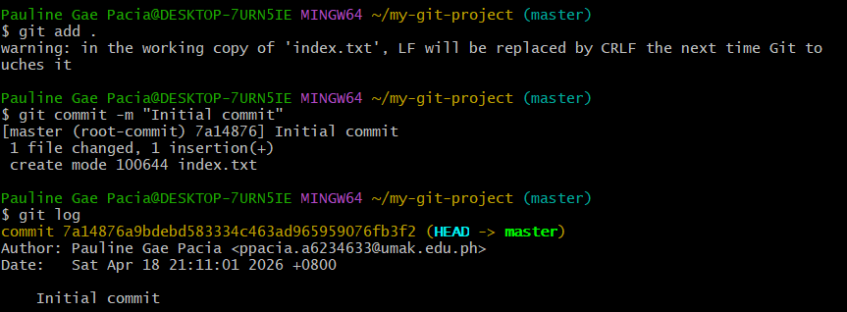

Section B: Safe Experimentation via Branching
To avoid overwriting each other's code, developers use branches to create a separate version of the project.

2. Creating a Feature Branch
- Leave the default main (or master) branch.
- Create and switch to a new branch using git checkout -b feature-login.
- Add a new file or make a significant change to an existing file.
- Stage and commit the changes on this new branch (git add . and git commit -m "Add login feature").
- Run git branch to view all branches and confirm the current active branch (indicated by the * symbol).

Screenshot/s of Section 1.B.
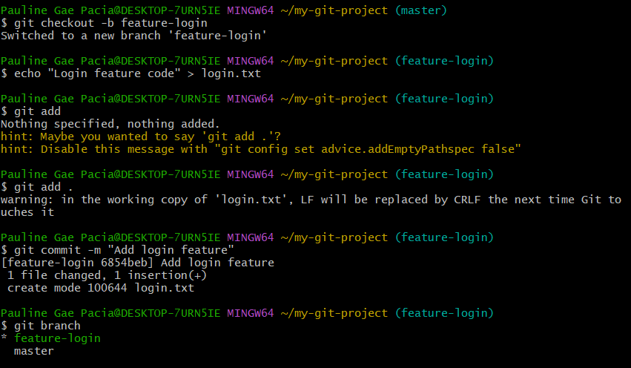

Section C: Creating & Resolving a Merge Conflict
Merge conflicts happen when Git cannot decide which version of a file to keep because two branches modified the same line. Students will now intentionally create and fix one.

3. Trigger and Resolve a Conflict
- Switch back to the main branch using git checkout main.
- Edit the same line in the same file that was changed in the feature-login branch.
- Stage and commit this change to main.
- Attempt to combine the branches using git merge feature-login.
- Observe the Conflict: Git will highlight the conflict using markers (<<<<<<< HEAD, =======, >>>>>>>).
- Resolve: Open the file, choose which code is correct, delete the conflict markers, save the file, and run git add and git commit to finalize the merge.

Screenshot/s of Phase 1.C.
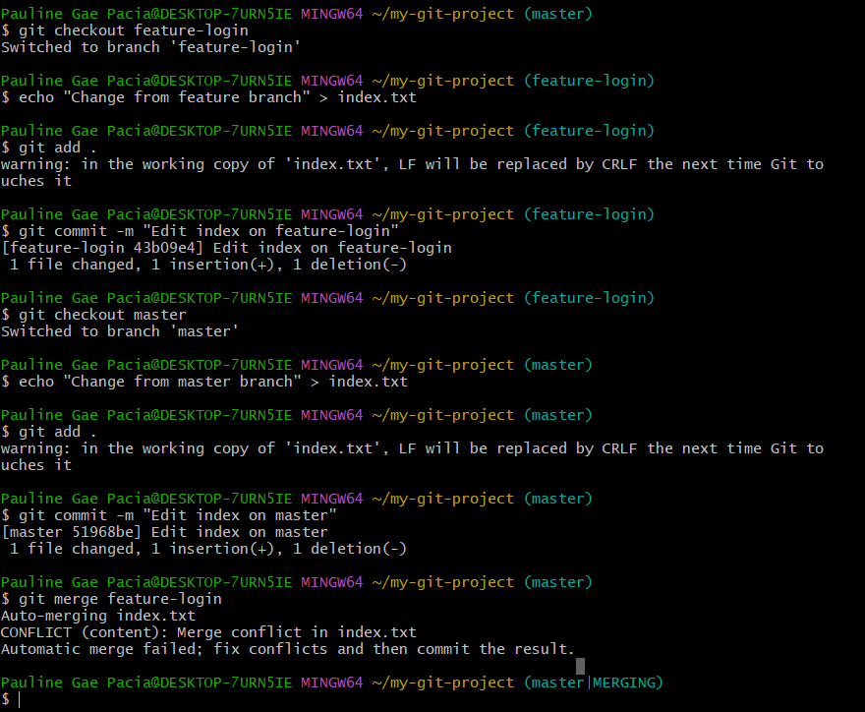
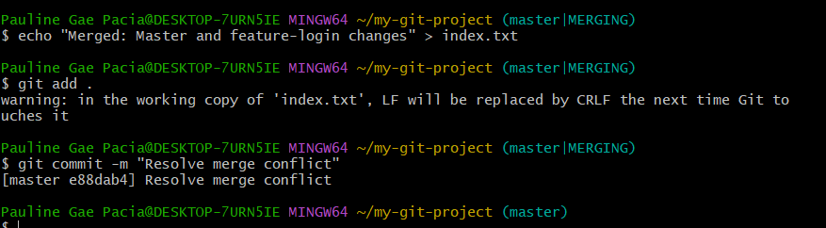

Section D: Connecting to GitHub
Git is a local, offline tool, while GitHub is a cloud-based platform for hosting repositories. Students will push their local work to the cloud to collaborate anywhere.

4. Uploading to the Cloud
- Log in to GitHub and create a new Public repository.
- Link the local Git repository to GitHub using the command: git remote add origin <repository_URL>.
- Send the local code to the internet using git push origin main.
- (Optional) Explore the concept of a Pull Request on GitHub, which allows team members to review code before it is merged into the target branch.

Screenshot/s of Phase 1.D.
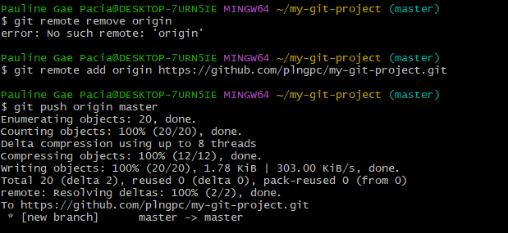

Part 2: "Clone & Branch" - Working with an Existing Codebase

Section A: Downloading the Repository
To work on an existing project, you must first copy the repository from the internet to your local computer. A repository is your project folder that contains all the code files, commit history, and branches.
- Open your web browser and go to the public GitHub repository link provided by your instructor to verify the files exist online.
- Open your terminal or command prompt and navigate to the directory where you want to store your project.
- Download the code by typing the command: git clone <repository_URL>.
- Wait for the terminal to finish "receiving objects" and "resolving deltas."
- Use the cd command in your terminal to move inside the newly downloaded project folder.
- Run the ls (Mac/Linux) or dir (Windows) command to list the files and ensure everything downloaded correctly.
- Check the existing history and previous contributors of the pre-made files by typing git log.

Screenshot/s of Phase 2.A.
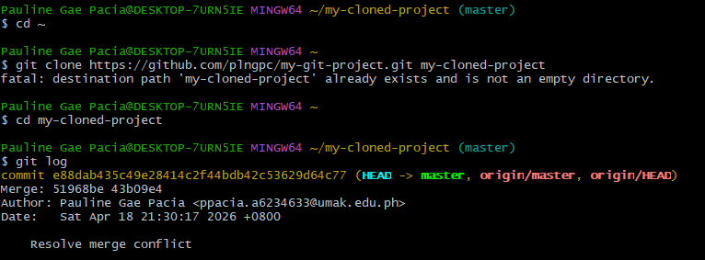

Section B: Creating a Safe Workspace
Since this is an existing project, you should not edit the main branch directly, as it contains the stable and working code. You must create a branch to work independently without affecting others.
- Create a new workspace branch and automatically switch to it using the command: git checkout -b my-feature-update.
- Run git branch to verify you are currently on your new branch (look for the * symbol and Launch your Code Editor (e.g., VS Code) and open the project folder you cloned earlier.
- Navigate through the file structure and locate the specific files.
- Add new lines of code, fix a identified bug, or complete the code template as required.
- Save your changes in the editor before returning to the terminal.
Screenshot/s of Phase 2.B.
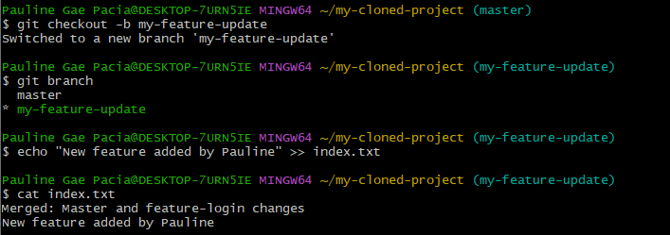

Section C: Tracking the Edits
Now that you have modified the pre-made files, you need to save those changes using the Three Zones of Git.
- Run git status to see a list of the specific files you modified in the Working Directory.
- Move your changes from the Working Directory into the Staging Area (the "waiting room") using the command: git add ..
- Run git status again to confirm the files are now in the Staging Area (they should appear in a different color).
- Permanently save your changes into the Repository (the "vault") with a clear, descriptive message: git commit -m "Updated the pre-made files".
- Review the log one last time with git log --oneline to see your new commit at the top of the history.

Screenshot/s of Phase 2.C.
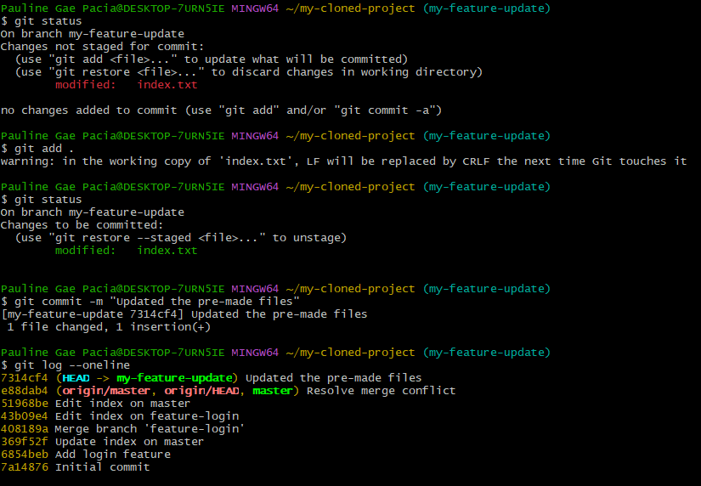

Section D: Merging the Updates locally
Merging means combining the changes from your feature branch back into the main branch.
- Prepare to merge by switching back to the stable main branch using the command: git checkout main.
- Verify that your editor has automatically reverted to the original version of the code.
- Bring your completed work from your feature branch into the main project by running: git merge my-feature-update.
- Observe the terminal output for "Fast-forward" to confirm the integration was successful.
- Open your Code Editor one last time to verify that your main branch now contains the edits you made earlier.
Screenshot/s of Phase 2.D.
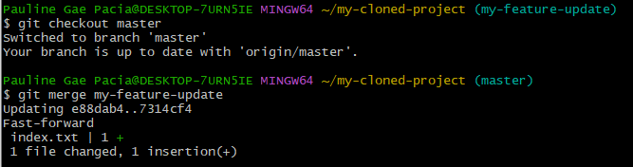
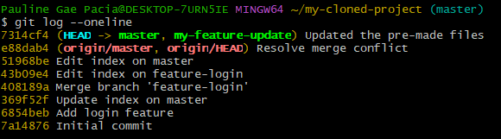

Section E: Reflection
Answer the following questions based on the workflow you just practiced:
What is the exact purpose of the git clone command?
It downloads a complete copy of a remote repository including all files, history, and branches to your local machine.

In a real-world scenario, why is it dangerous to skip branching and make direct edits to a pre-made repository's main branch?
You could accidentally break the stable working code on main. Branches let you work safely without affecting others.

What is the difference between git clone and git pull?
git clone is a one-time download of an entire new repo. git pull updates an existing local repo with the latest changes from remote.

If you were working with a remote team on this pre-made project, what feature on GitHub would you use to let the team review your code before merging it?
A Pull Request (PR) — it lets teammates review and approve your code before merging into the main branch.

